Intermediate Virtualization

Project: Continuous Integration using GitHub Actions

Weight: 25% Marks: /100

Student Name:

Student ID:

Date:

This page was intentionally left blank.

Table of Contents

Project: Continuous Integration using GitHub Actions 2

Introduction 2

Equipment and Materials 2

Procedure 3

Part A: Create a Node.js Web App and Push to GitHub 3

Part B: Create a GitHub Actions Workflow 7

Part C: Demonstrations 10

Marking Criteria 13

Resources 14

References 14

Instructor Notes 14

# Project: Continuous Integration using GitHub Actions

## Introduction

CI tools run builds and tests, which are triggered by commits. The goal is fewer bugs in production and faster feedback while developing. In this project, you’ll combine independent research with the concepts you’ve learned in the course to create workflows that enable you to use continuous integration (CI) for your projects. The goal of this project is to create a GitHub Actions workflow that automates code integration.

While GitHub Actions can be used to implement continuous integration and continuous delivery, we are only doing continuous integration in this project.

This project relies on your ability to seek out information in course documents and online resources to determine the appropriate steps to achieve your desired result. You’ll then demonstrate your completed project to your instructor.

Continuous Integration: A "Typical" Process (<https://developers.redhat.com/blog/2017/09/06/continuous-integration-a-typical-process>)

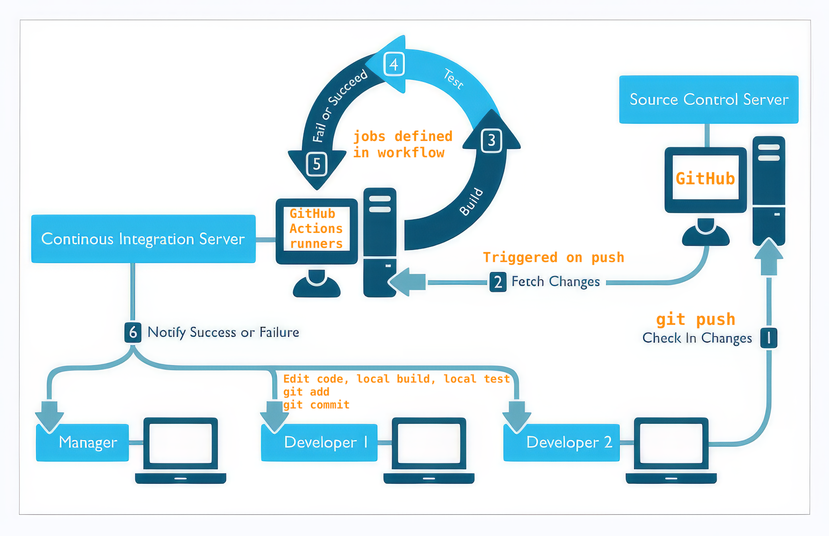

## Equipment and Materials

* Windows computer with a minimum of 32 GB RAM and 250 GB free disk space.
* VMware Workstation 16.x or higher
* Ubuntu Linux (22.04 LTS or higher) or RHEL/AlmaLinux/Rocky Linux (9.0 or higher)
* Git
* Node.js
* Docker Engine
* GitHub account
* Docker Hub account

## Procedure

### Part A: Create a Node.js Web App and Push to GitHub

GitHub runs CI tests and provides the results of each test. When all CI tests in the workflow pass, GitHub packages your application with its environment and all its dependencies into a container and publishes it to Docker Hub for delivery.

**Note:** Complete this part of the project individually, outside of class time.

1. Install Node.js on the Linux VM. <https://nodejs.org/en/download/package-manager>
2. Download and unzip the file **github-actions-ci-base.zip** to a folder. You can find it in Brightspace.
3. Create a Dockerfile that contains all the required commands to build a container image.  
   **Hint**: <https://www.smashingmagazine.com/2023/04/building-dockerizing-nodejs-app-stateless-architecture-kinsta/> Step 2 has example code for the Dockerfile.  
   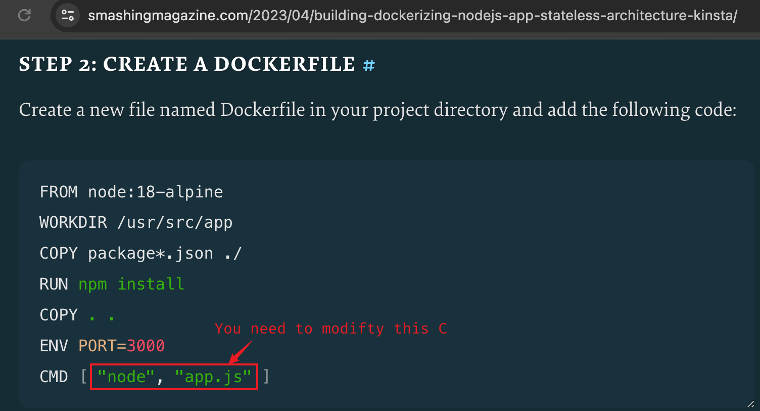
4. Create an empty file called **main.yml** under the **.github/workflows** folder.

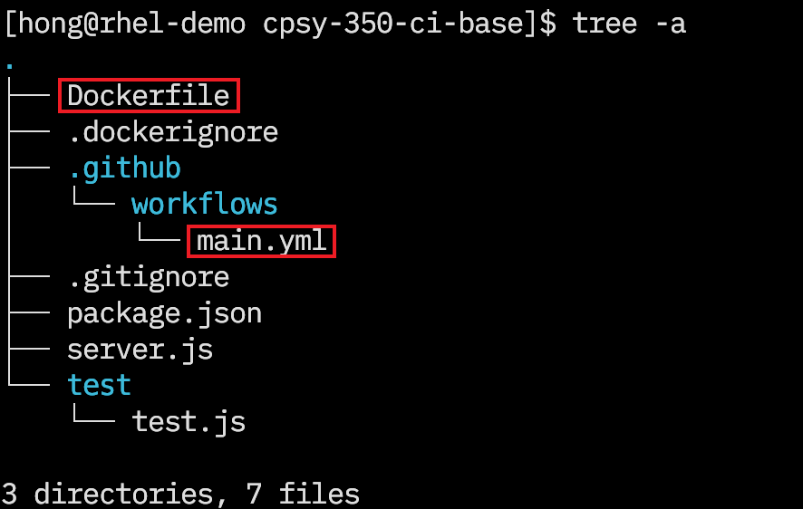

Figure 1: Dockerfile and Workflow File

© 2024, Southern Alberta Institute of Technology

1. Use `**npm install**` to build, `**npm test**` to test and `**npm start**` to start the web server locally. Verify the web application with **curl** command or browser.

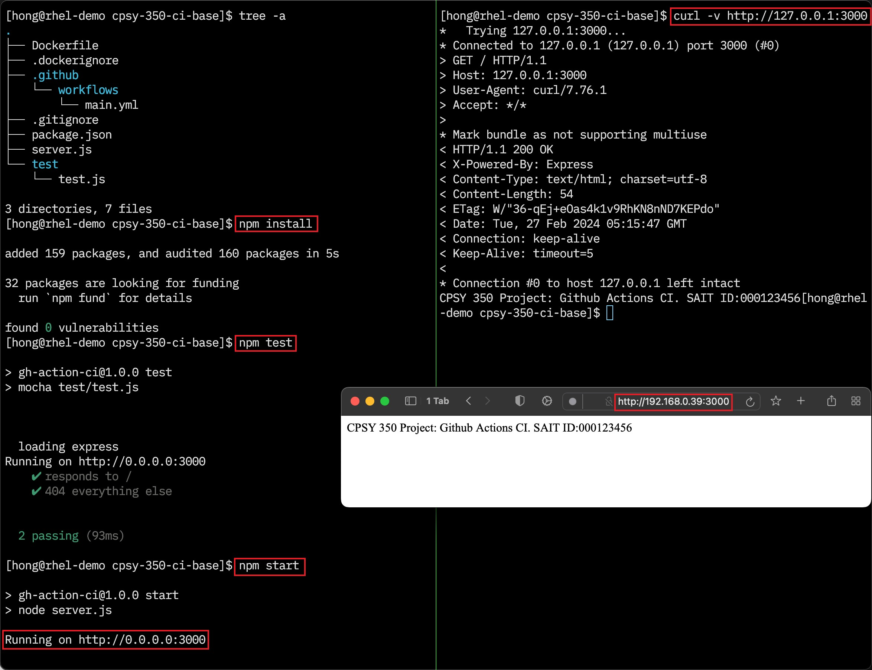

**Figure 2: Build, Test and Verify the Web Application**

© 2024, Southern Alberta Institute of Technology

1. Go to github.com and create a new, **private** repository.

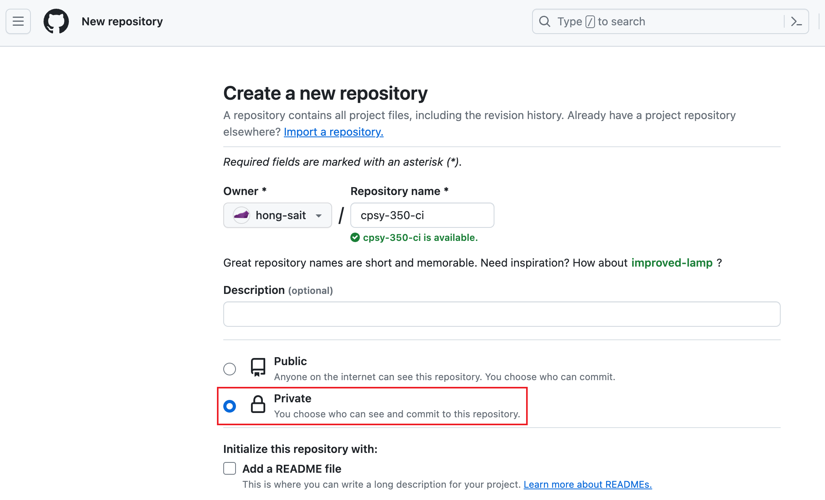

Figure 3: Create a Private GitHub Repository

Source: GitHub, Inc., 2024. Reproduced and used in accordance with the fair dealing provisions in section 29 of the Canadian Copyright Act for the purposes of education, research or private study. Further distribution may infringe copyright.

1. Create a **README.md** file and commit to local repository.  
   Read [Git - Recording Changes to the Repository (git-scm.com)](https://git-scm.com/book/en/v2/Git-Basics-Recording-Changes-to-the-Repository)

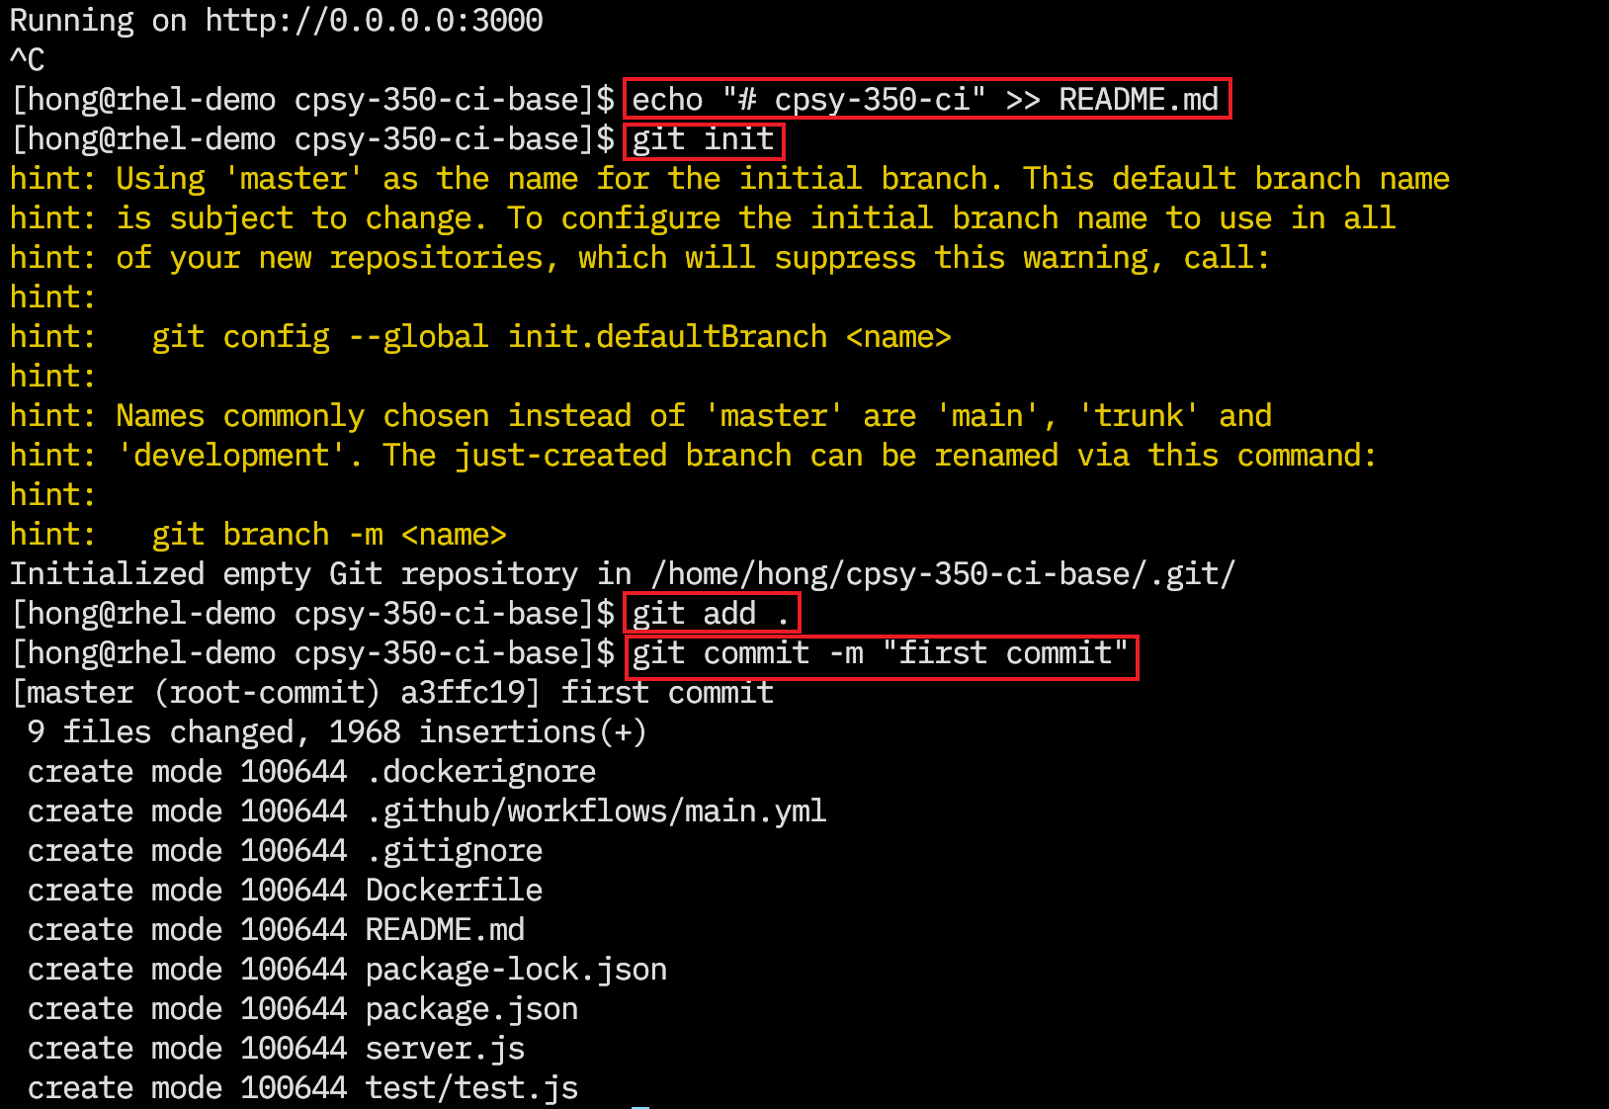

Figure 4: Push Code to GitHub

© 2024, Southern Alberta Institute of Technology

1. Before pushing your local repository to GitHub, ensure that a SSH key has been added to your GitHub account.  
   [Adding a new SSH key to your GitHub account - GitHub Docs](https://docs.github.com/en/authentication/connecting-to-github-with-ssh/adding-a-new-ssh-key-to-your-github-account)  
   <https://www.youtube.com/watch?v=X40b9x9BFGo>  
   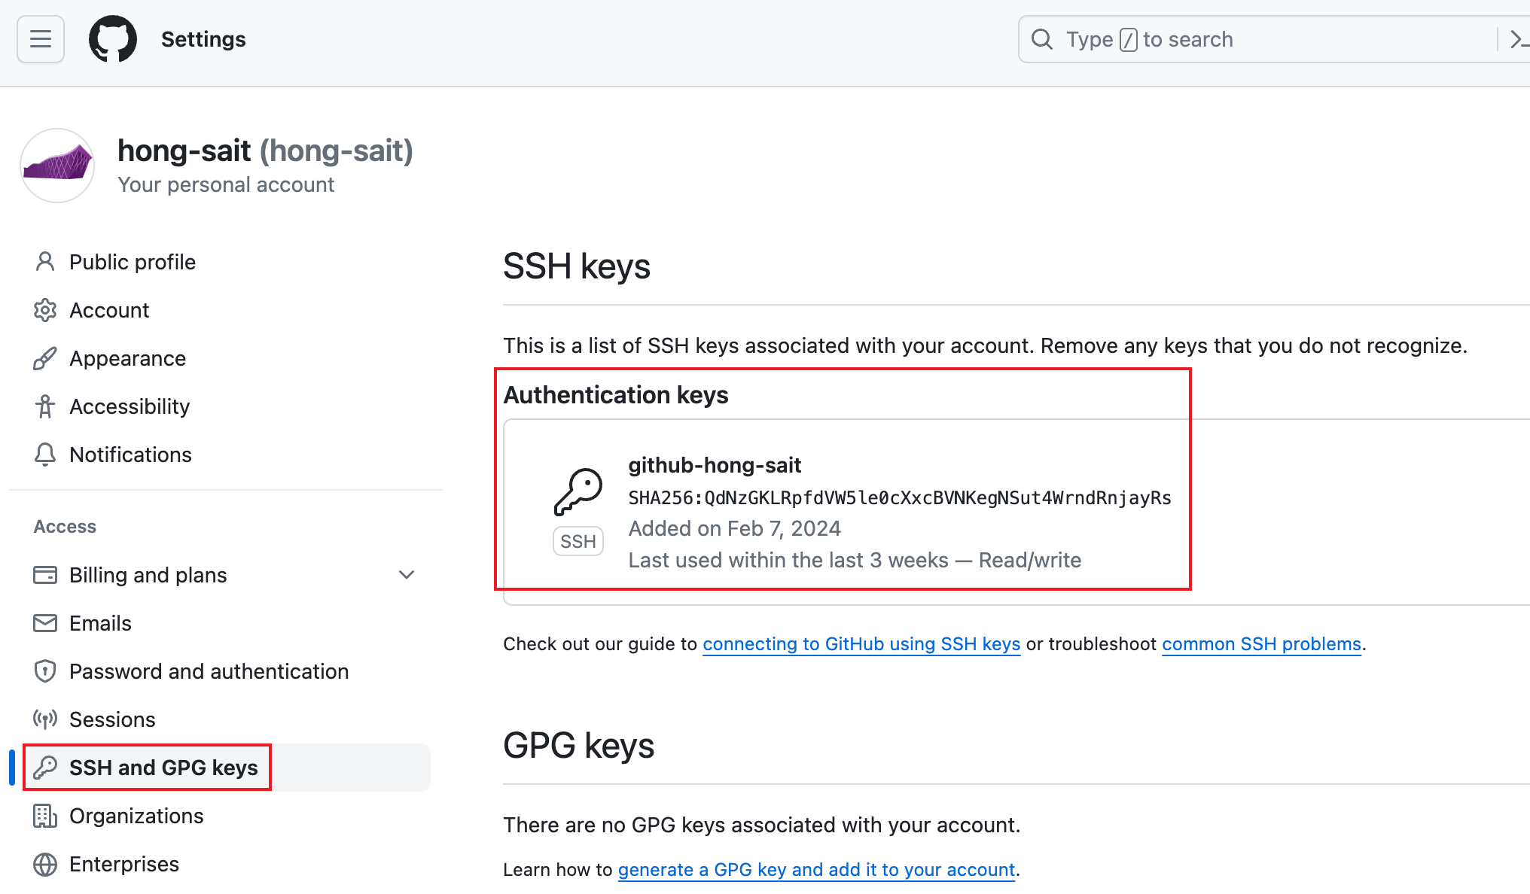
2. [Generating a new SSH key and adding it to the ssh-agent - GitHub Docs](https://docs.github.com/en/authentication/connecting-to-github-with-ssh/generating-a-new-ssh-key-and-adding-it-to-the-ssh-agent)  
   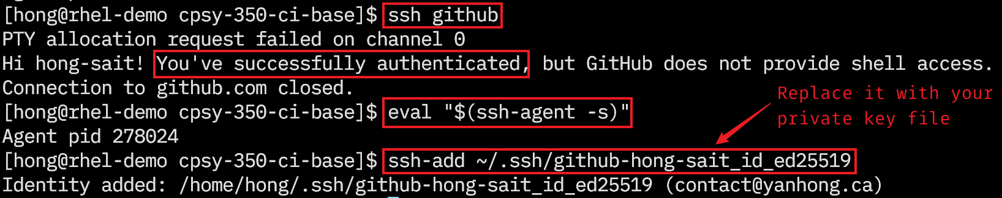
3. Follow the instructions on GitHub to push the local repository to your GitHub repository.  
   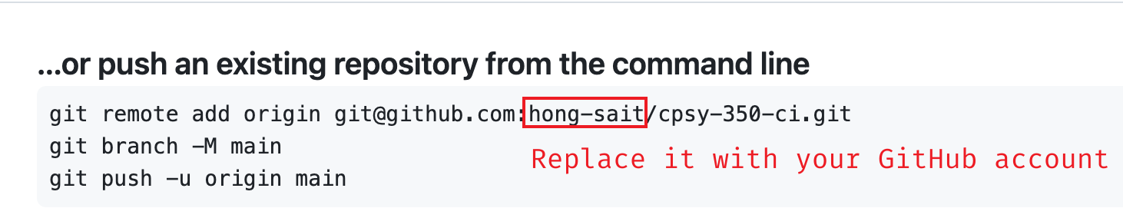
4. If you encounter `**git@github.com: Permission denied (publickey).**` error, set up key based GitHub authentication in Part A.8 and Part A.9  
   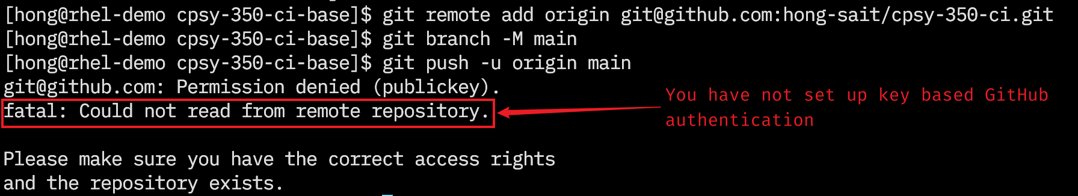
5. Ensure that your local repository has been pushed to GitHub successfully.  
   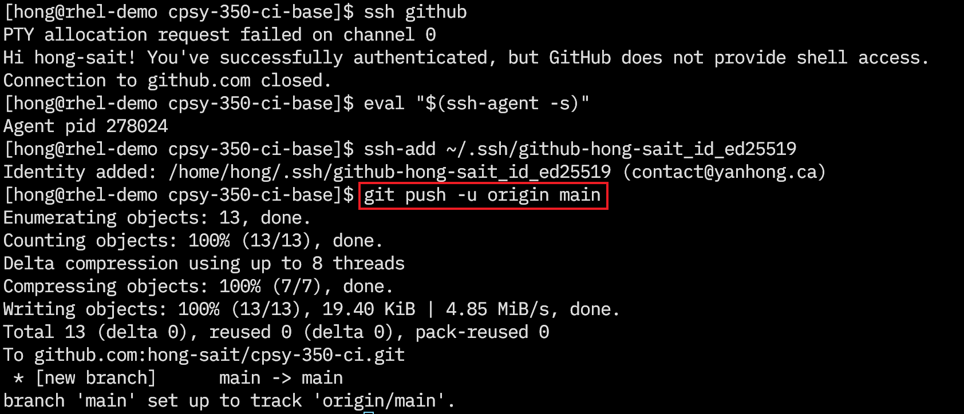
6. Visit your repository on GitHub and verify that files under the GitHub cpsy-350-ci repository are the files in your local repository.

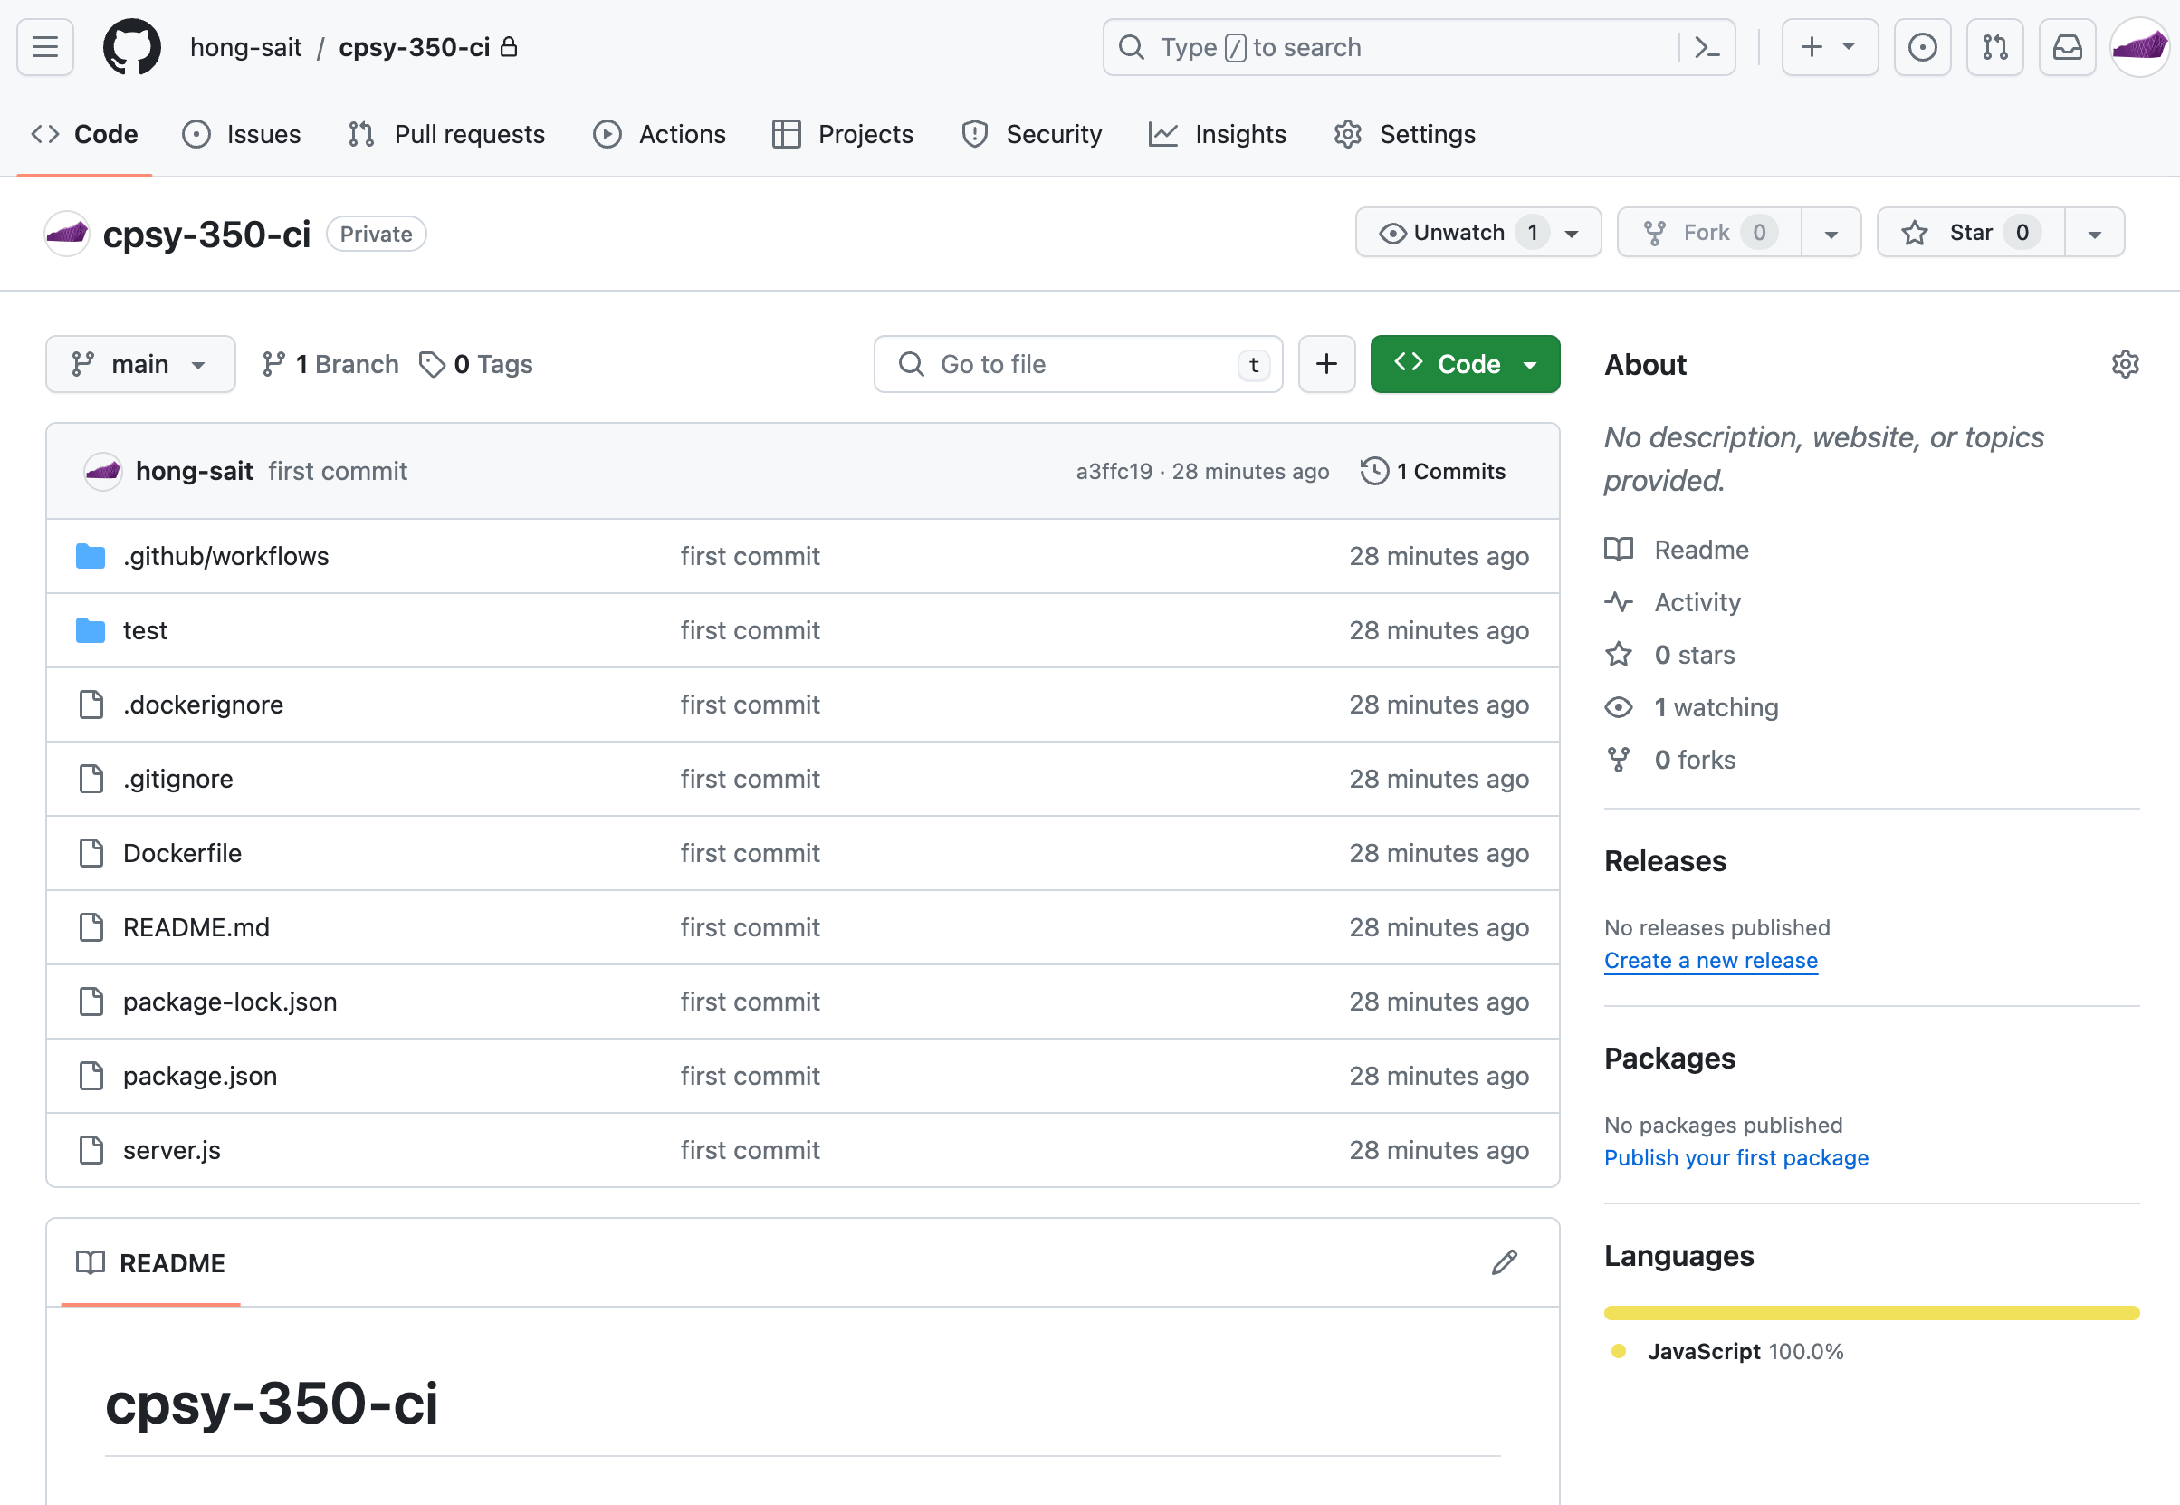

Figure 5: Verify GitHub Repository

Source: GitHub, Inc., 2024. Reproduced and used in accordance with the fair dealing provisions in section 29 of the Canadian Copyright Act for the purposes of education, research or private study. Further distribution may infringe copyright.

1. Go to Docker Hub and create a **public** repository.  
   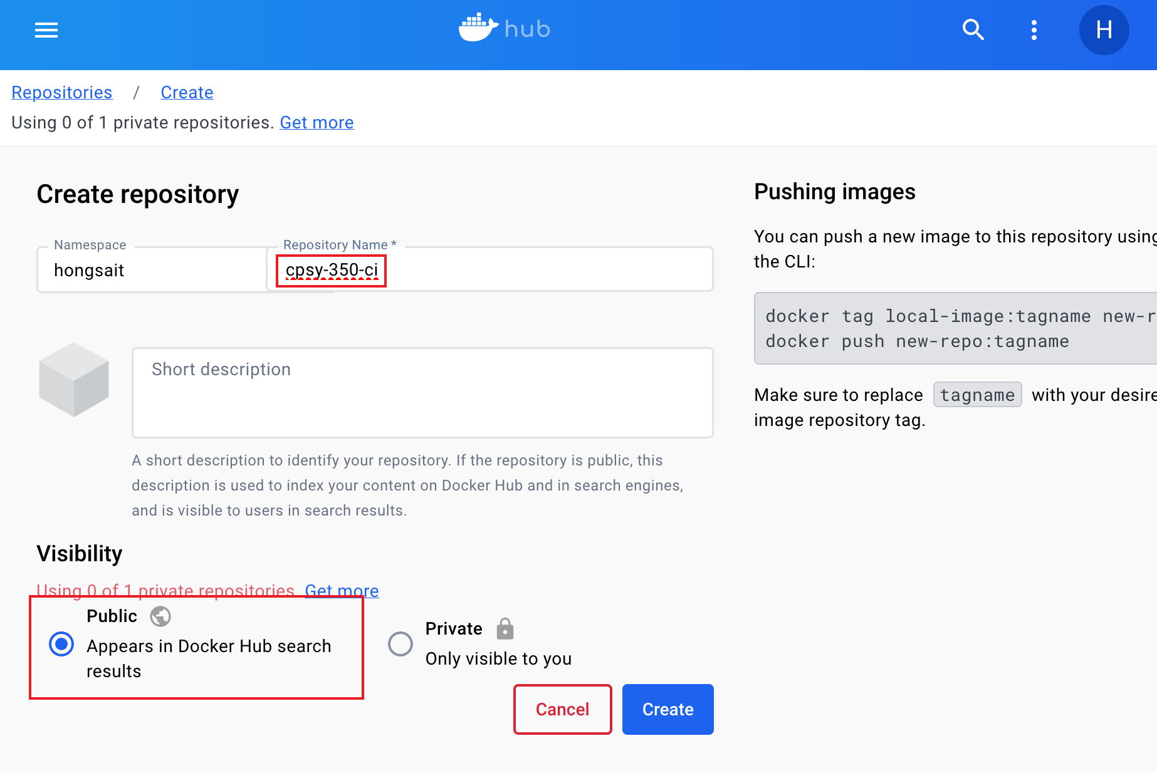
2. Create a Docker Hub access token. <https://docs.docker.com/security/for-developers/access-tokens/>

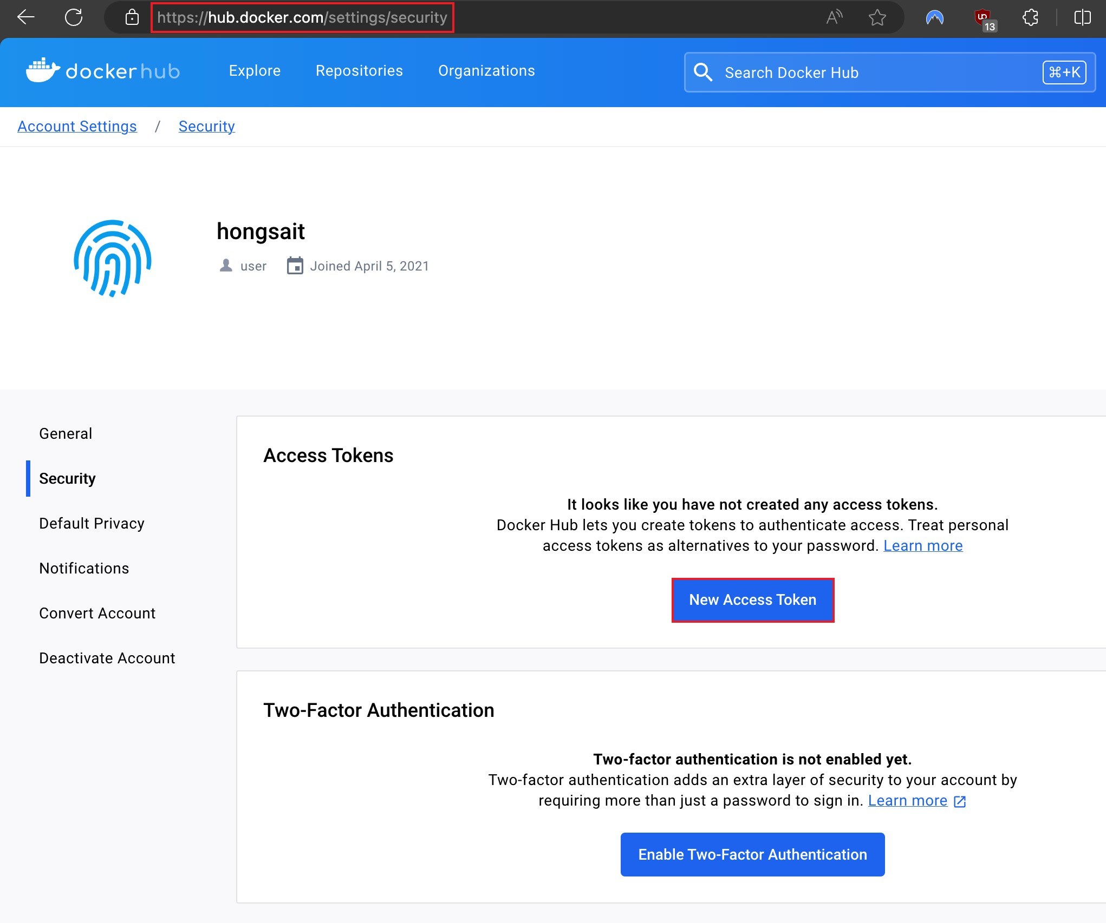

Figure 6: Create a Docker Hub Access Token

Source: Docker, Inc., 2024. Reproduced and used in accordance with the fair dealing provisions in section 29 of the Canadian Copyright Act for the purposes of education, research or private study. Further distribution may infringe copyright.

After you create the access token, it will only be displayed once. Ensure that you copy the token and save it in a file.  
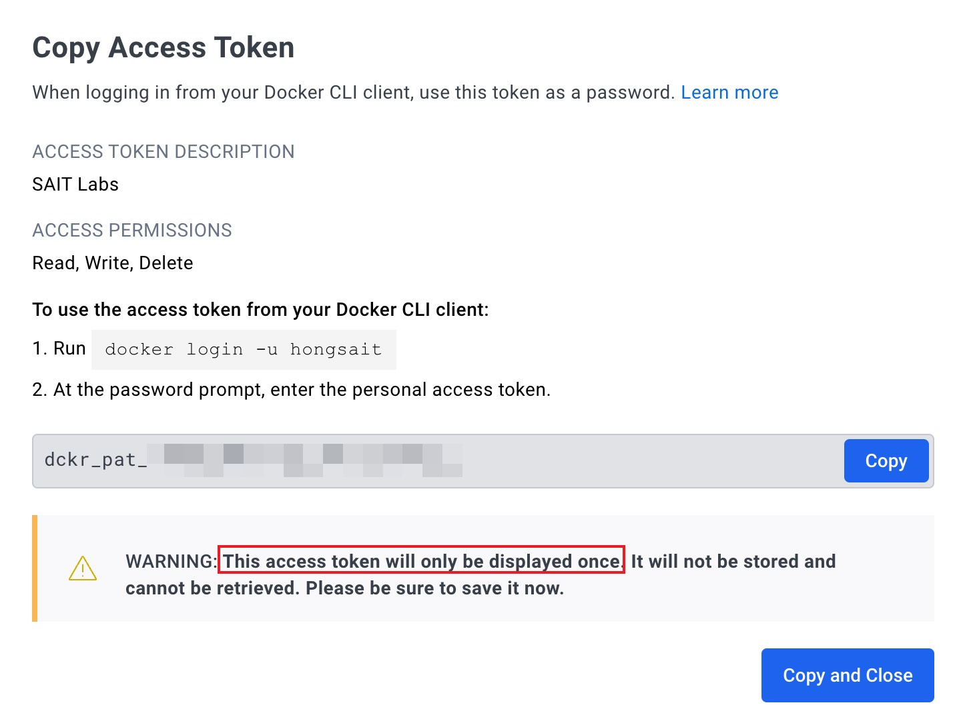  
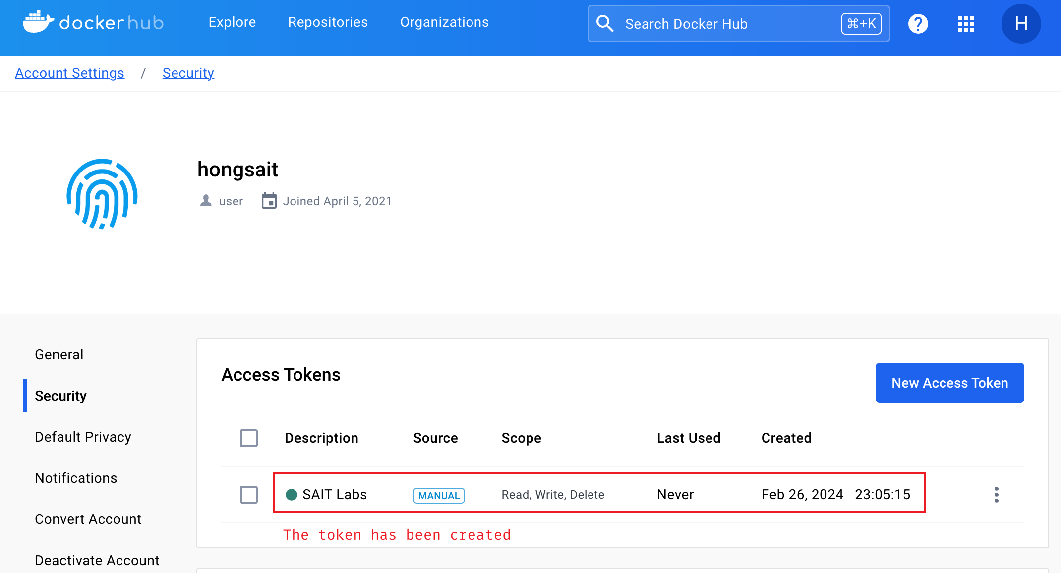

Verity that the created access token can be used to login Docker Hub  
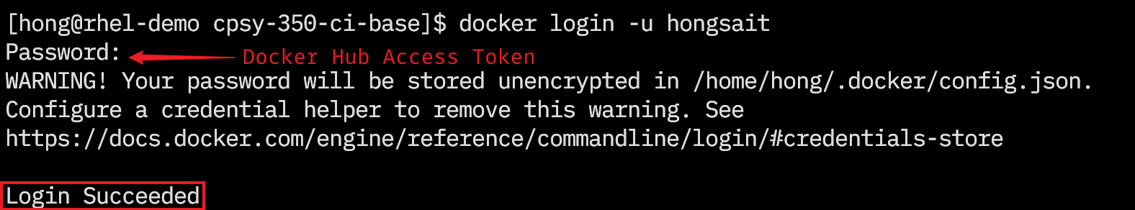

### Part B: Create a GitHub Actions Workflow

A workflow is a unit of automation from start to finish, and includes the definition of what triggers the automation, what environment or other aspects should be taken account during the automation, and what happens when the automation is triggered.

1. To keep your passwords and tokens safe, use **Actions Secrets** to store your Docker Hub login credentials (Docker Hub username and access token created in Part A.15).

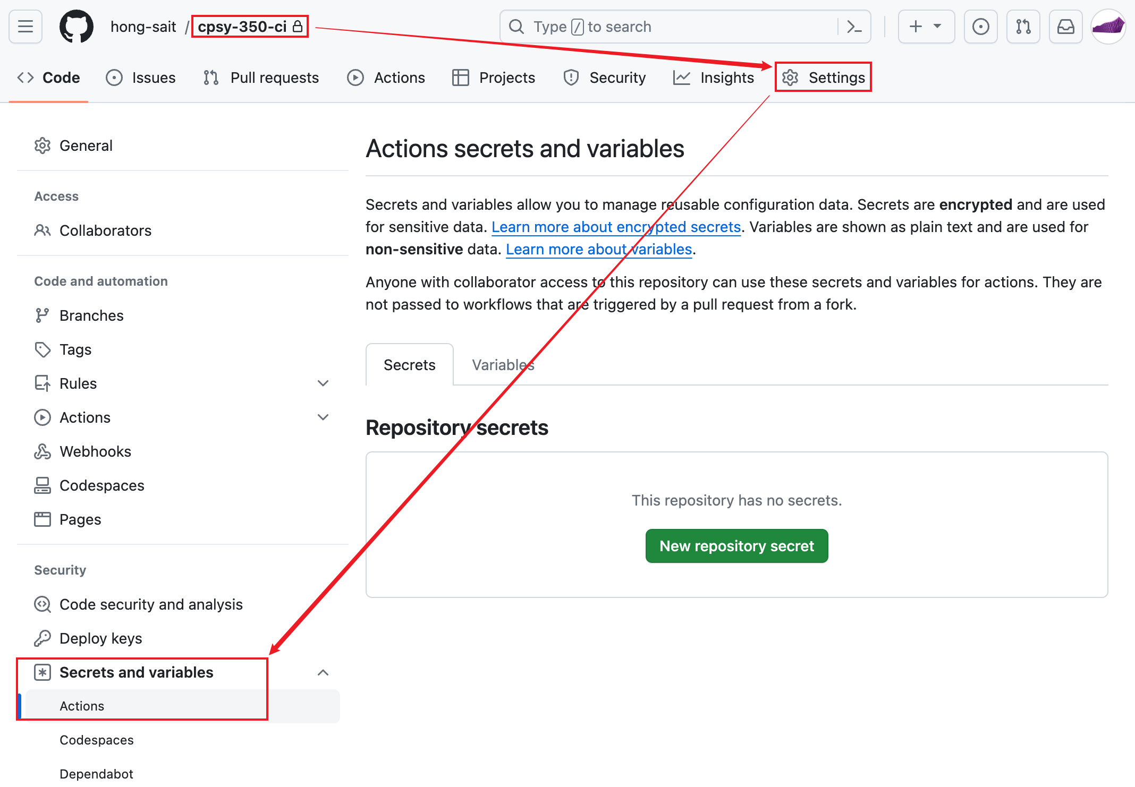 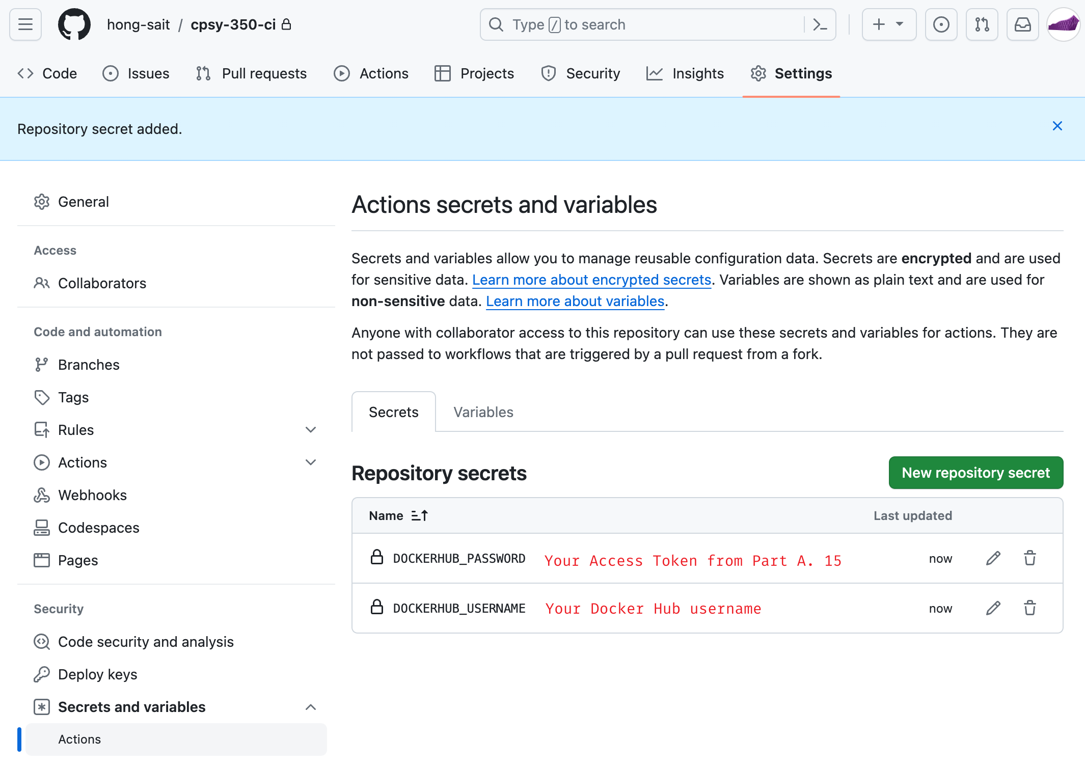

Figure 7: GitHub Actions Secrets

Source: GitHub, Inc., 2024. Reproduced and used in accordance with the fair dealing provisions in section 29 of the Canadian Copyright Act for the purposes of education, research or private study. Further distribution may infringe copyright.

1. Create a workflow in **.github/workflows/main.yml** file. The first job of your workflow builds and tests the Node.js Web App. This job is triggered when you push a new code commit from local repository to the GitHub repository.   
     
   **Hint:** Read [Building and testing Node.js - GitHub Actions Docs](https://docs.github.com/en/actions/automating-builds-and-tests/building-and-testing-nodejs), modify the code under “you can build and test using a single version of Node.js too”  
   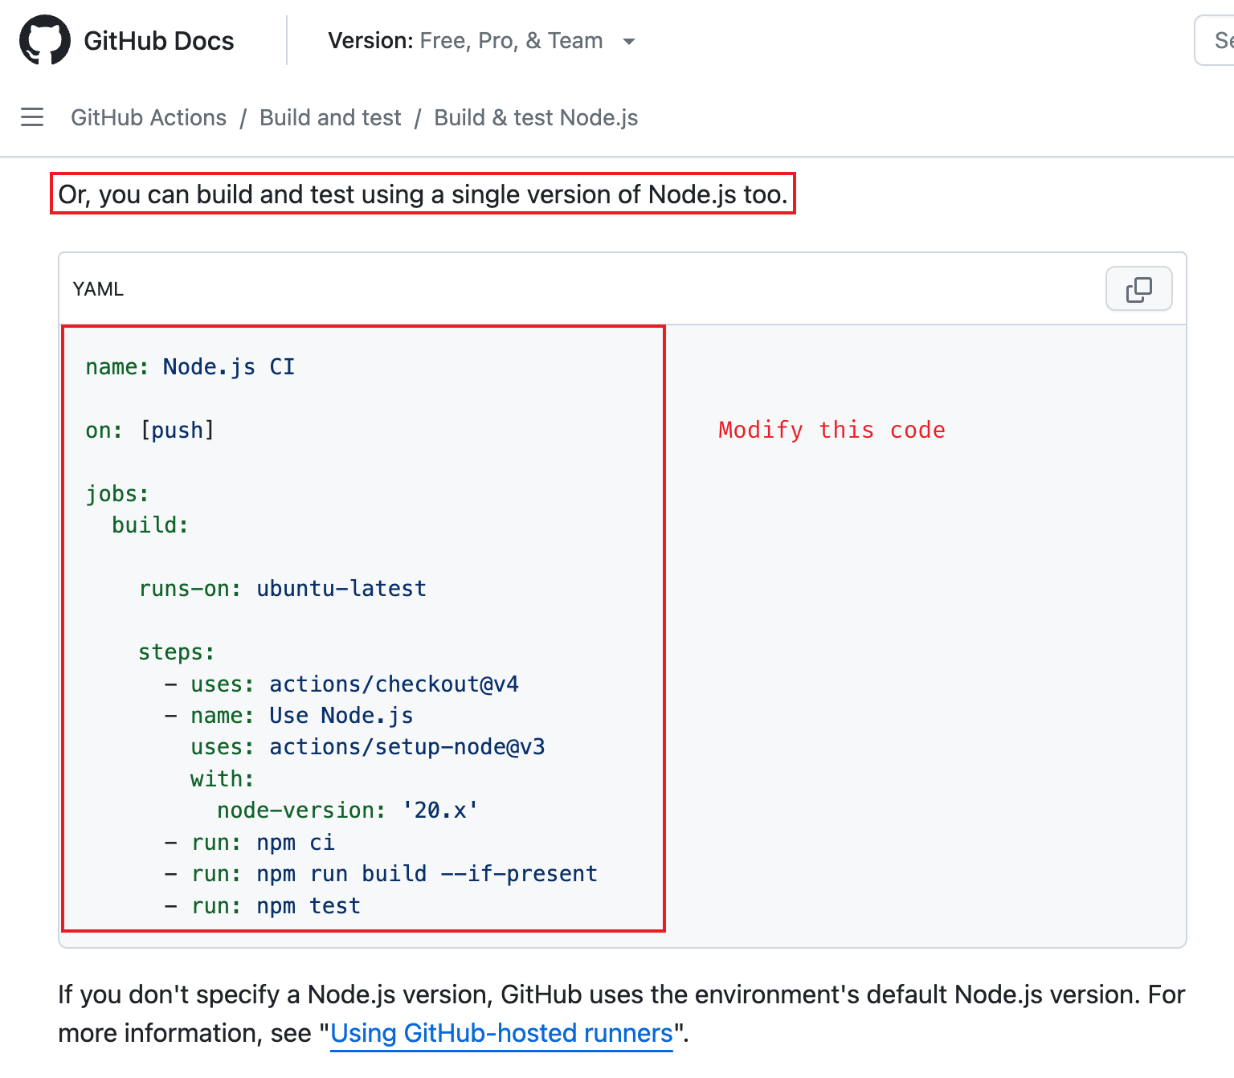

**Note:** A job is a section of a workflow, and it is made up of one or more steps. In this section of your workflow, the template defines the steps that make up the job.

1. Use **git** command to **add** the changes to **.github/workflows/main.yml** in the working directory to the staging area. Commit the change (The **git commit** command captures a snapshot of the project's currently staged changes. Committed snapshots can be thought of as “safe” versions of a project—Git will never change them unless you explicitly ask it to). Push the local repository to GitHub (The **git push** command is used to upload local repository content to a remote repository. Pushing is how you transfer commits from your local repository to a remote repo).  
   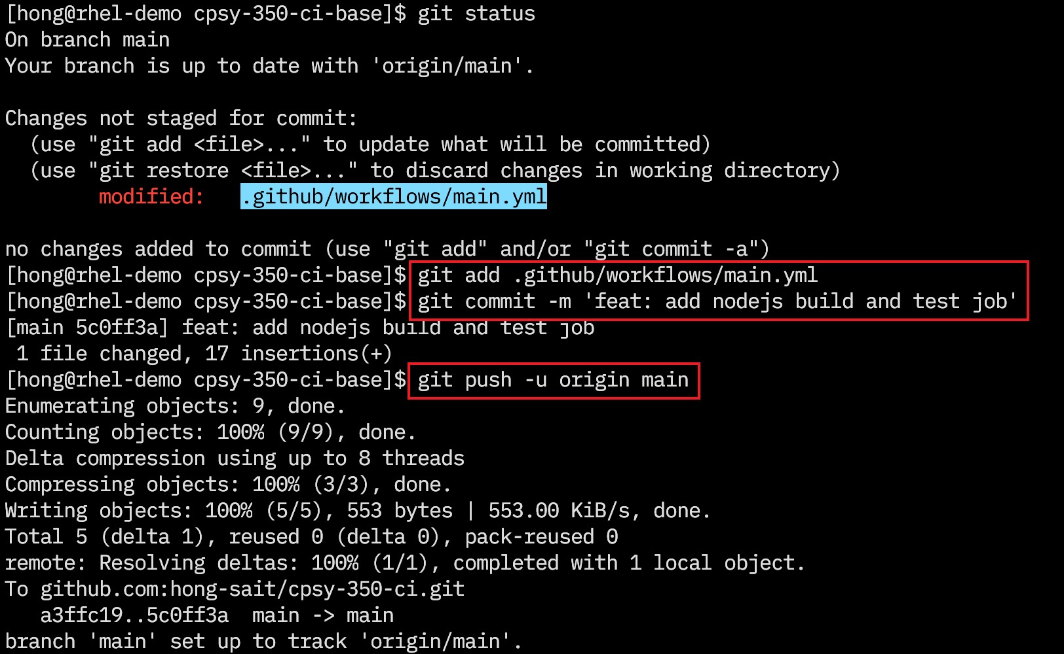
2. Go to your GitHub repository, verify that pushing local repo to GitHub repo has triggered the workflow and the first job defined in **.github/workflows/main.yml** has completed successfully.  
   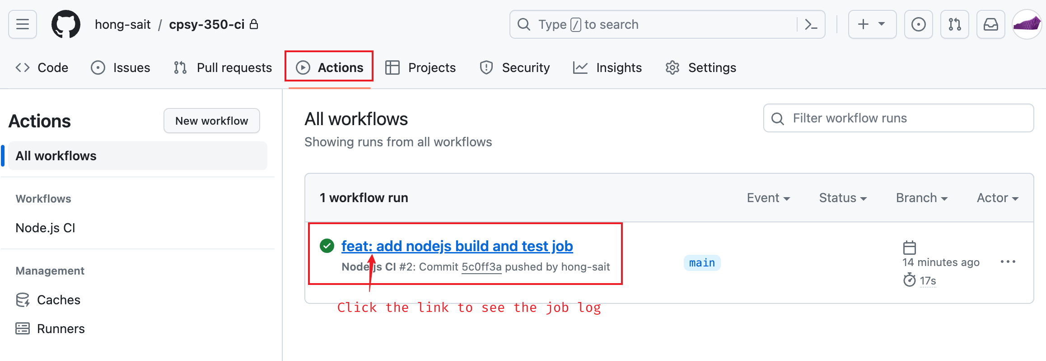  
   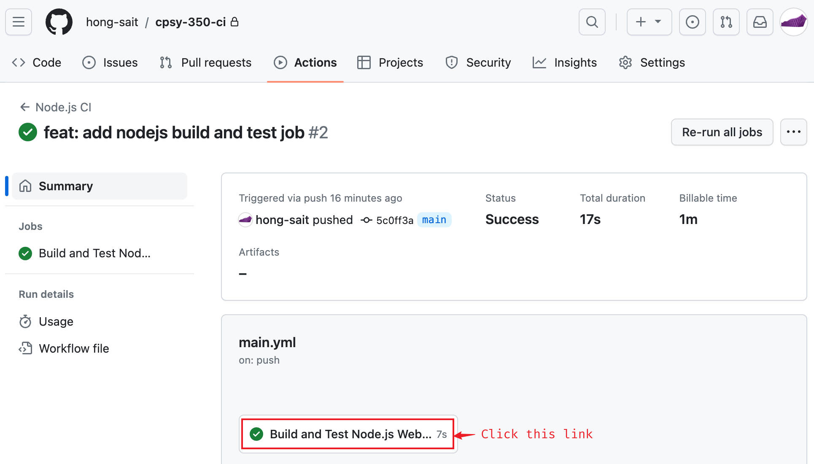  
     
   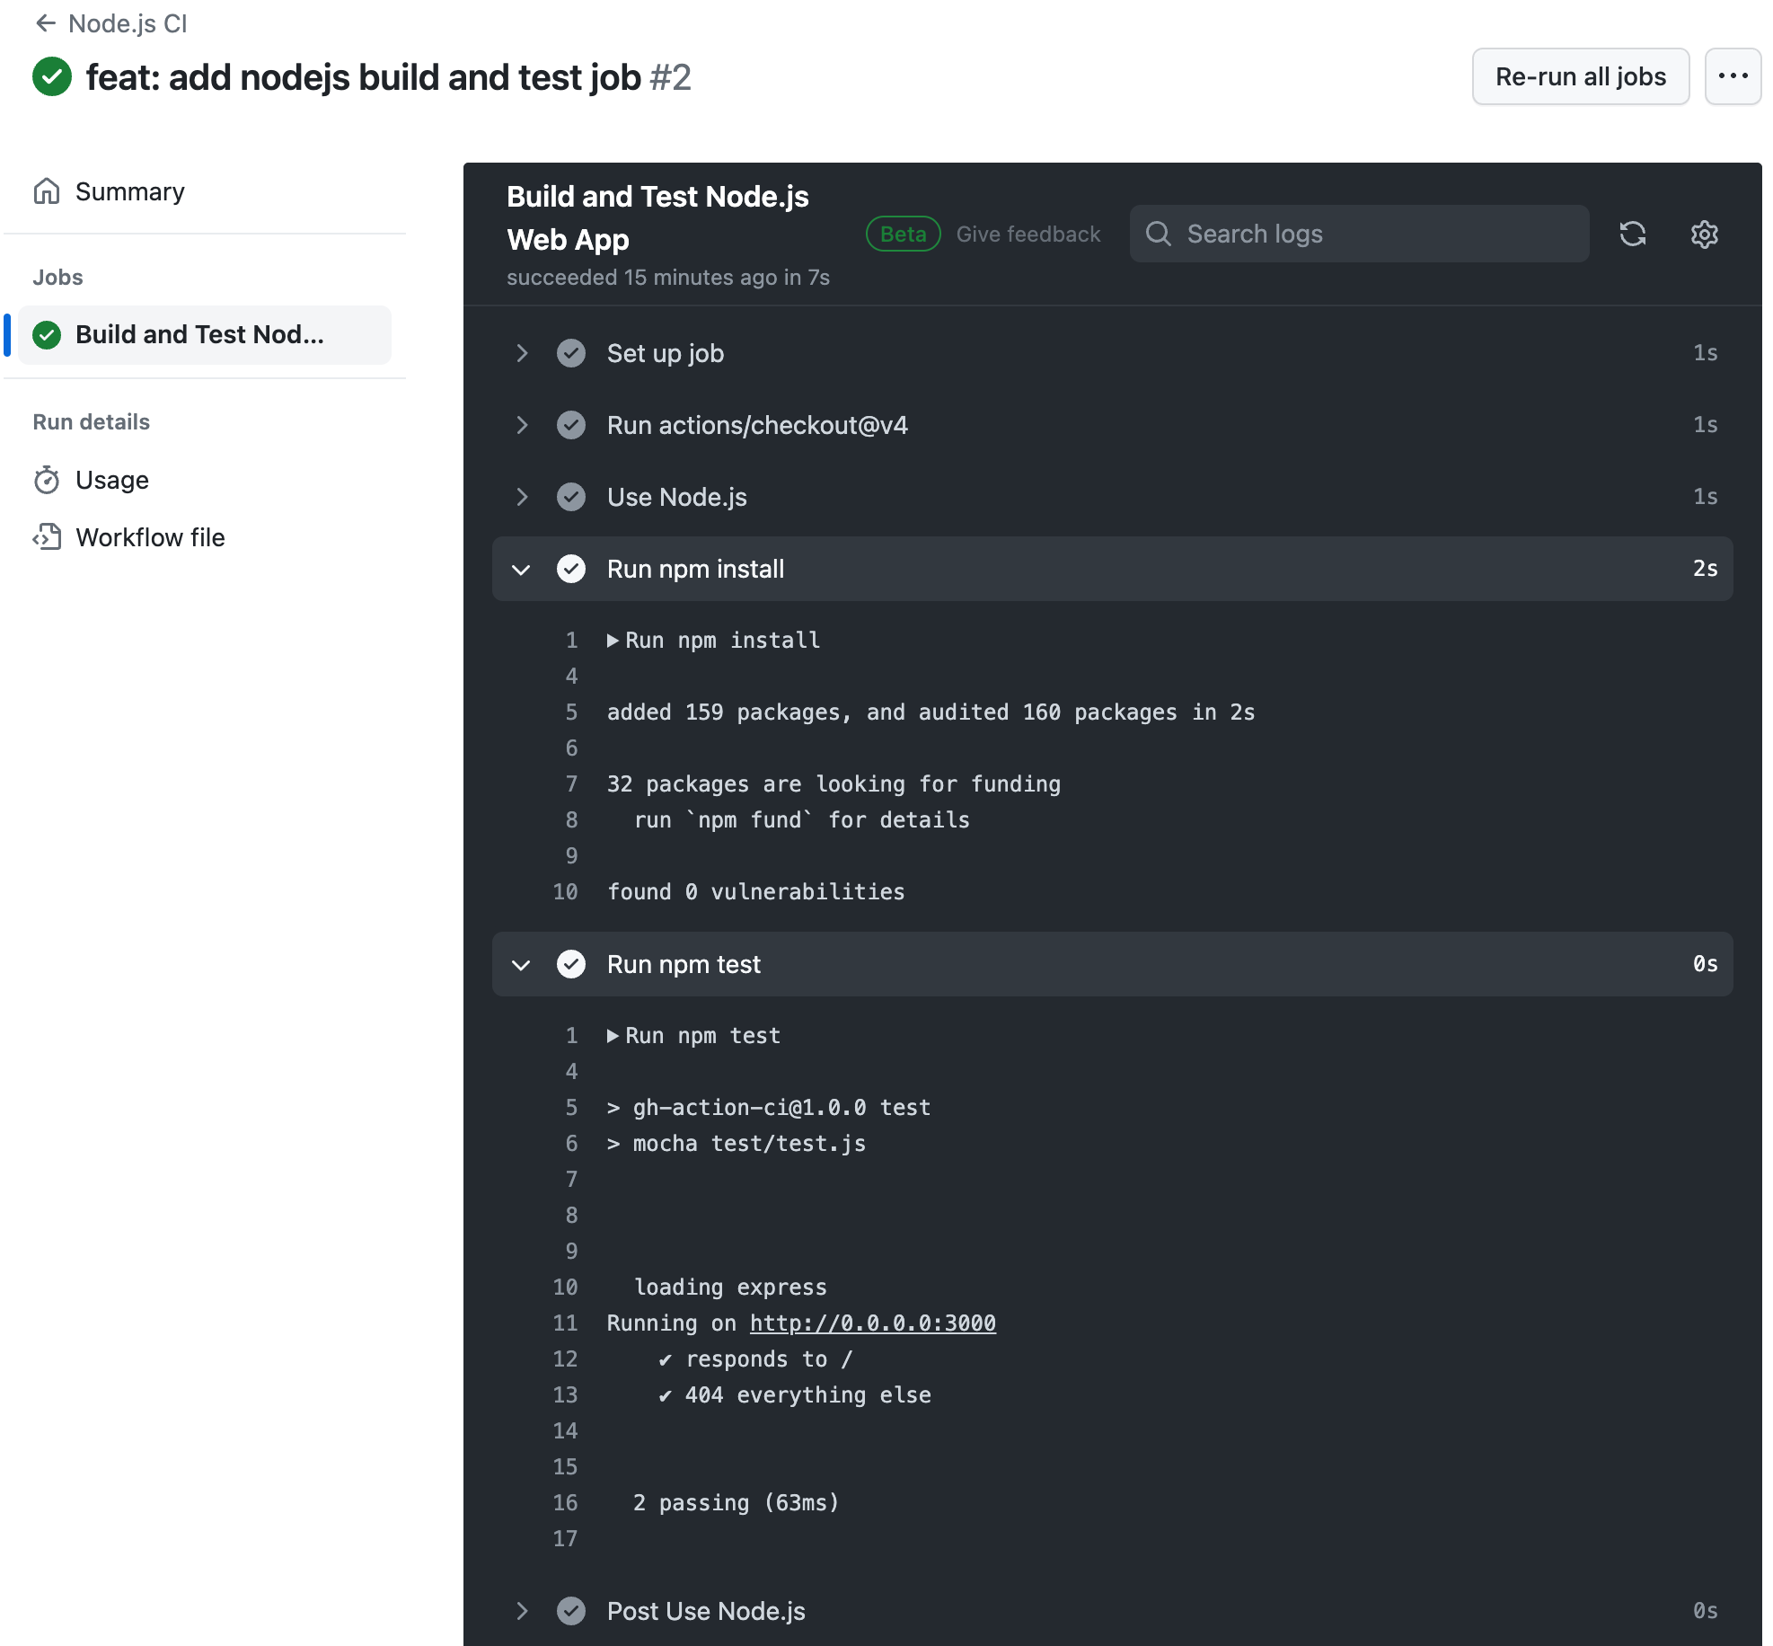
3. Verify that you have completed Part A. 3 and can build the OCI container image (Docker image) locally.   
   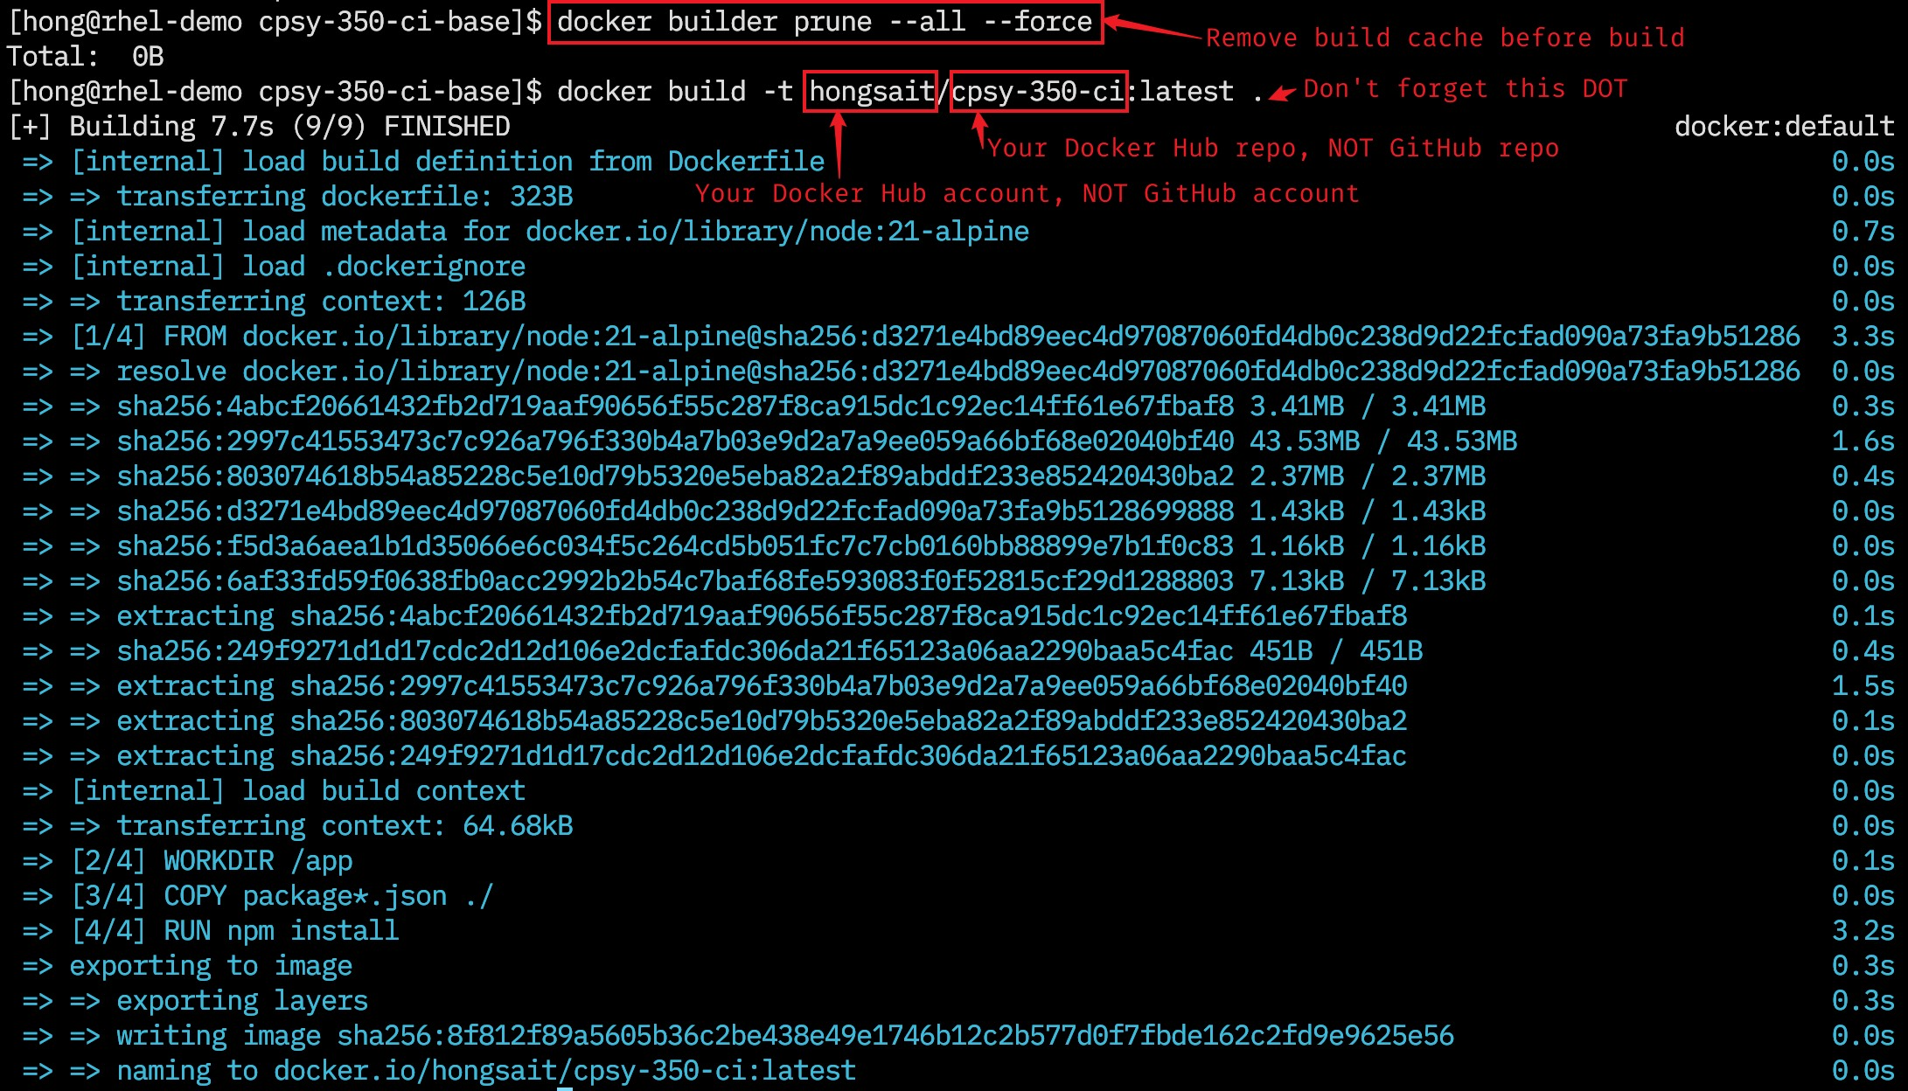
4. Verify that you can run the container locally and the web app is accessible.  
   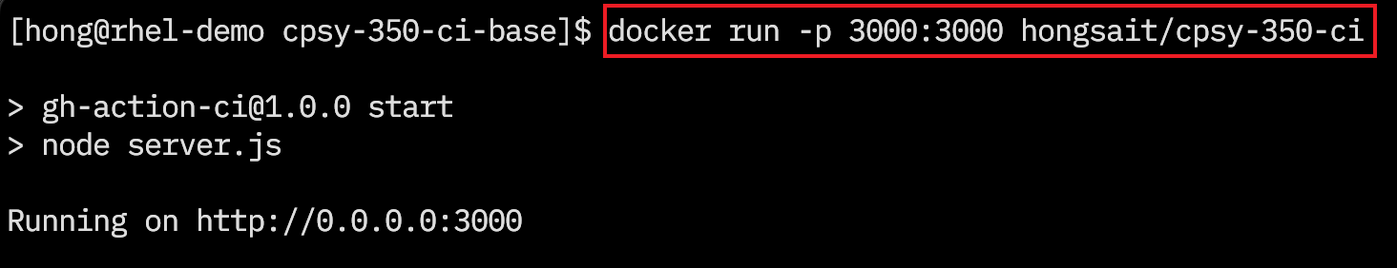  
   
5. Create the second job, which will be triggered **ONLY IF** the first job completes successfully (First job is prerequisite job of the second job). Read <https://docs.github.com/en/actions/using-jobs/using-jobs-in-a-workflow>.  
     
   This job builds the Node.js web app container image and publishes it to Docker Hub.  
   You need two steps for this job. The first step uses **docker/login-action** to login your Docker Hub account: <https://github.com/docker/login-action>. The second step uses **docker/build-push-action** to build and push container image to Docker Hub: <https://github.com/docker/build-push-action>   
     
   **Hint**: Modify the example code under “Git context” from <https://github.com/docker/build-push-action>. You can skip the “Set up QEMU” and “Set up Docker Buildx” steps, which are required for multi-architecture (Intel/AMD x64, ARM aarch64 etc.) build.  
     
   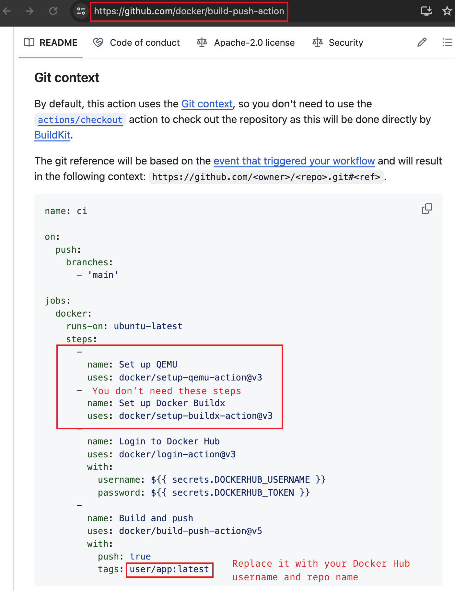
6. Verify that both job runs are successful.  
   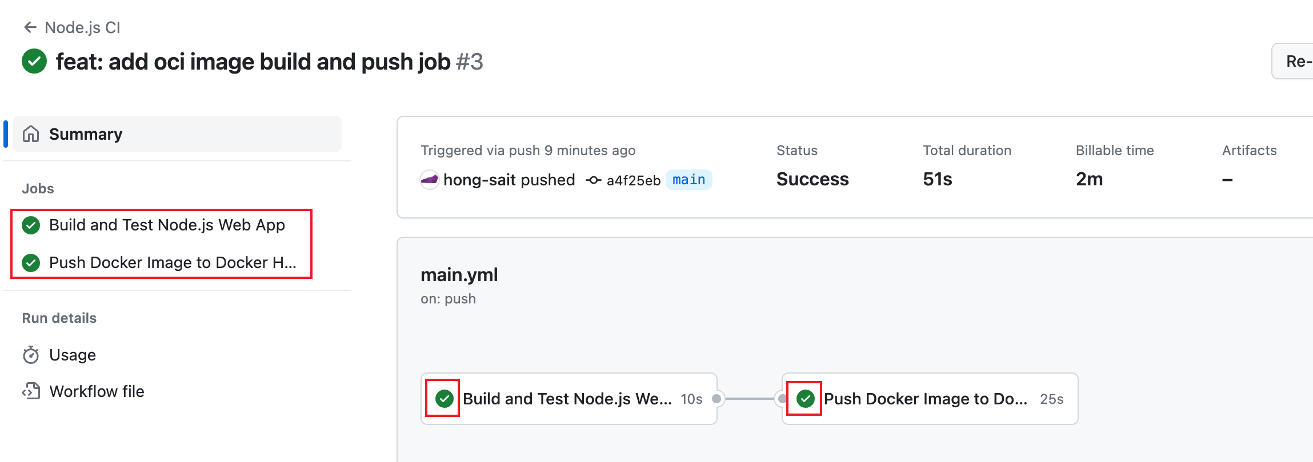

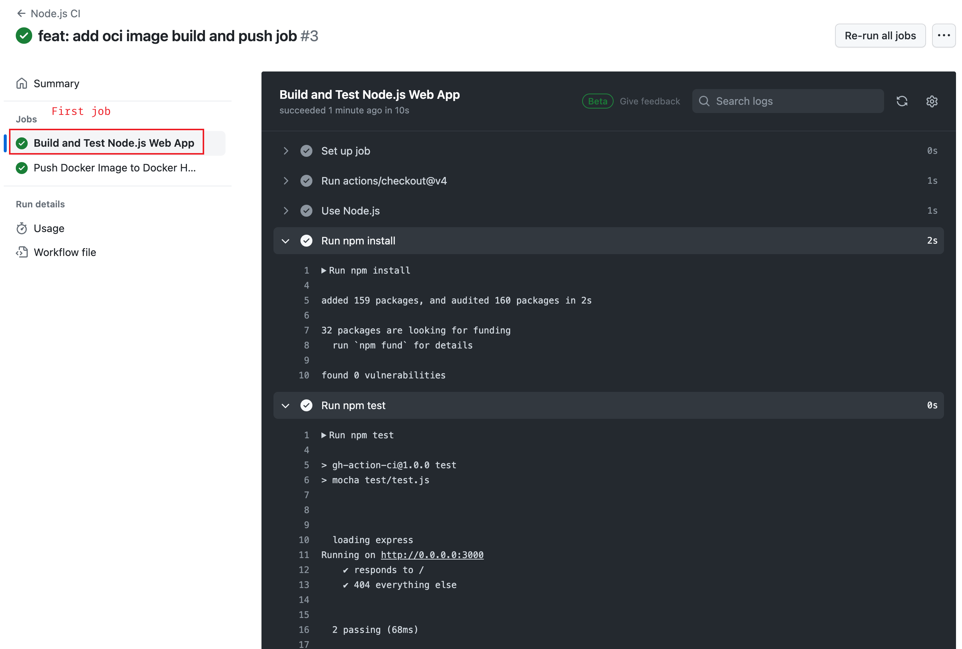

Figure 8: Creating GitHub Actions to Build and Test a Web Application

Source: GitHub, Inc., 2024. Reproduced and used in accordance with the fair dealing provisions in section 29 of the Canadian Copyright Act for the purposes of education, research or private study. Further distribution may infringe copyright.

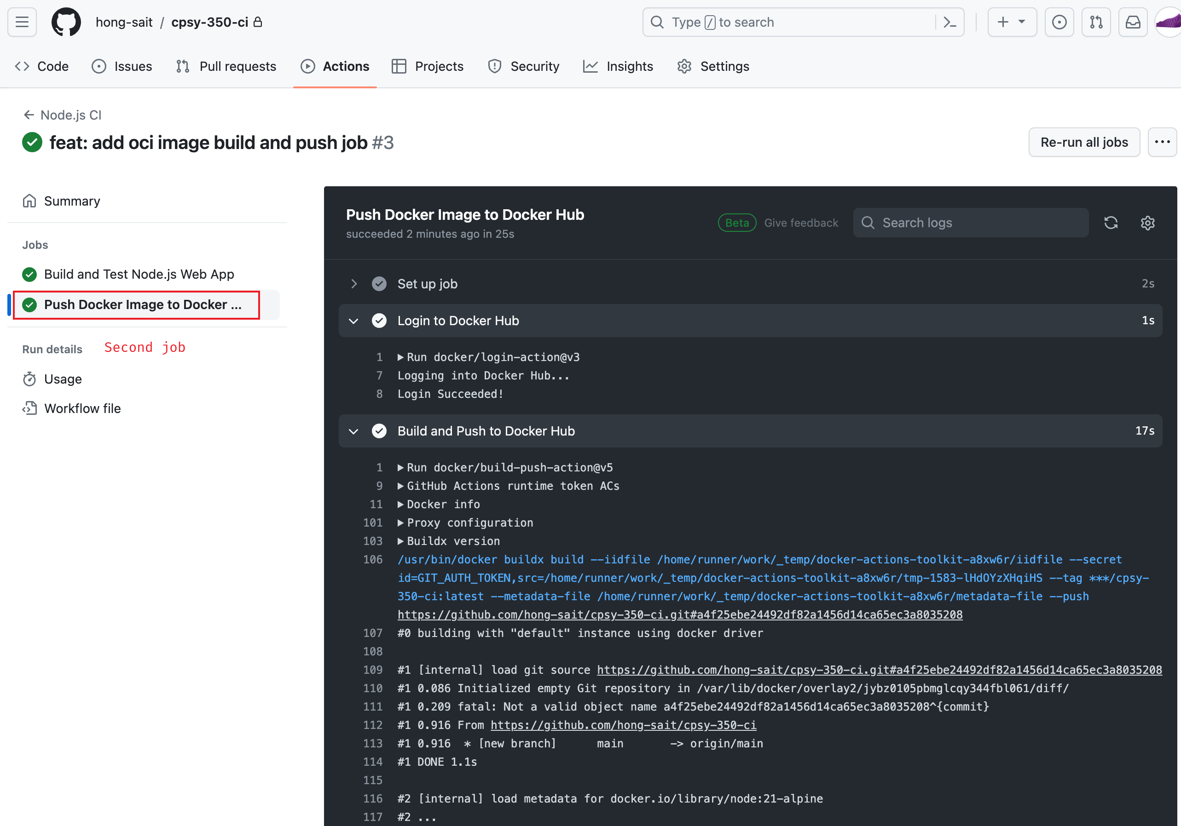

Figure 9: GitHub Action to Build and Push Container Image to Docker Hub

Source: GitHub, Inc., 2024. Reproduced and used in accordance with the fair dealing provisions in section 29 of the Canadian Copyright Act for the purposes of education, research or private study. Further distribution may infringe copyright.

### Part C: Demonstrations

In this section, you will conduct a live demonstration of what you’ve learned for your instructor. Your instructor will indicate whether this portion of the project will occur face to face or online. See the marking criteria at the end of this document for details of how you will be assessed.

Before you begin, replace the placeholder server response string in the **server.js** file with your SAIT ID.

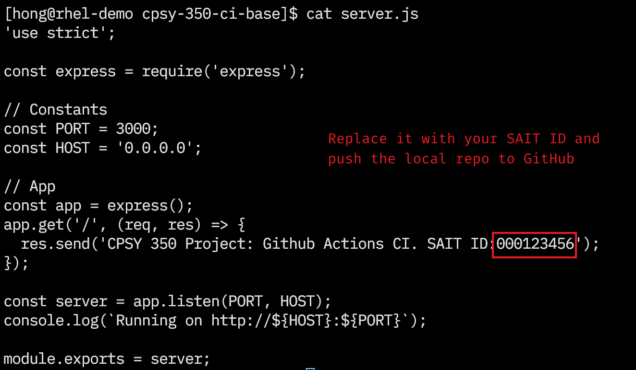

Figure 10: Modify the Server Response

Source: OpenJS Foundation, 2024. Reproduced and used in accordance with the fair dealing provisions in section 29 of the Canadian Copyright Act for the purposes of education, research or private study. Further distribution may infringe copyright.

1. **Demo 1:** Push the commit to your GitHub repository.
2. **Demo 2:** Show the references to the Docker Hub secrets you created earlier in the **.github/workflows/main.yml** file (These secrets should not be hard coded in that file).
3. **Demos 3–5:** Go to the **Actions** tab of the GitHub repository and demonstrate the CI jobs triggered by the push event.
   1. **Demo 3:** Show the first job being triggered.
   2. **Demo 4:** Show the first job occurring.
   3. **Demo 5:** Show the second workflow job occurring.

**Note:** The jobs in your workflow should not run at the same time. If the first job (Build and Test Node.js App) fails, the second job (Build and Publish Application Container) is skipped.



Figure 11: GitHub Actions Tab

Source: GitHub, Inc., 2024. Reproduced and used in accordance with the fair dealing provisions in section 29 of the Canadian Copyright Act for the purposes of education, research or private study. Further distribution may infringe copyright.

1. **Demo 6:** Show the container created from the published container image in Demo 5 running on your computer.
   1. Go to your Docker Hub repository and verify that the container image has been published.

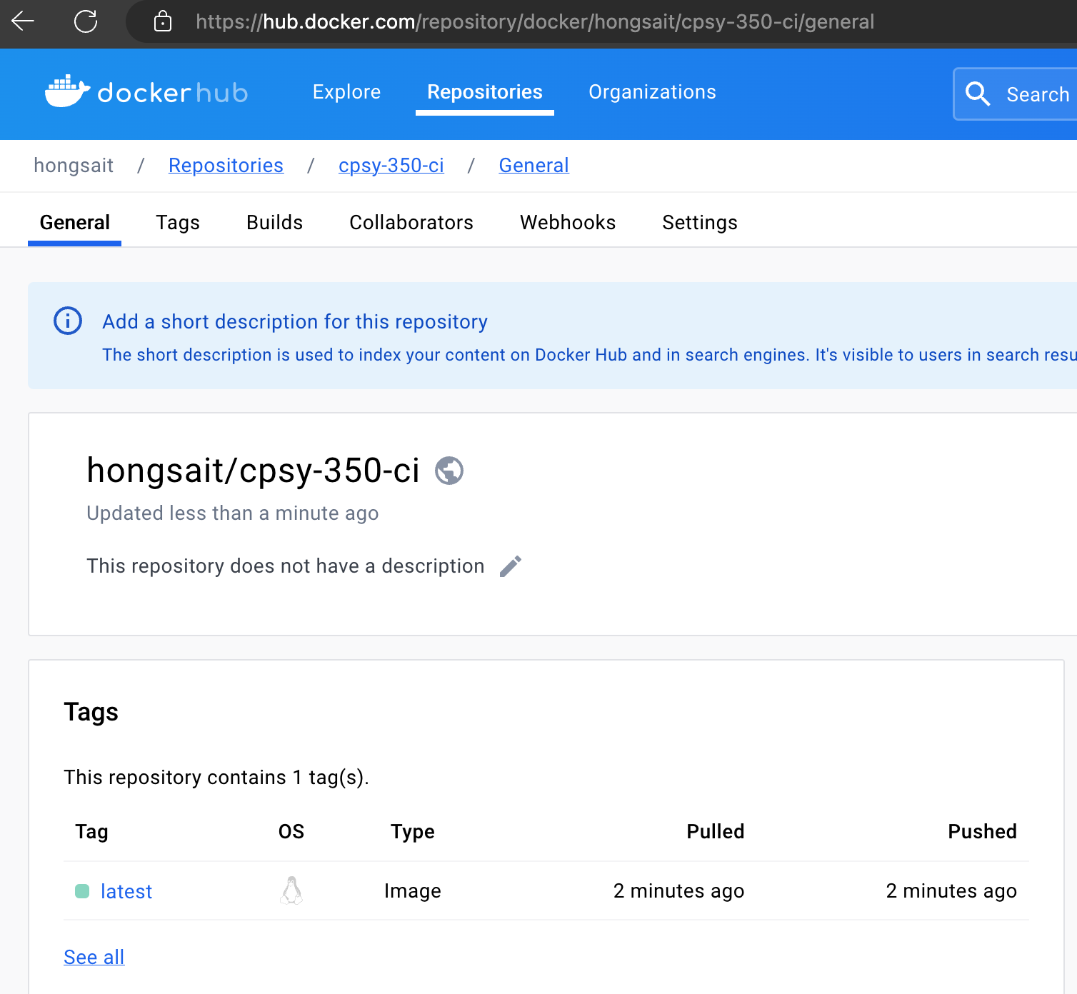

Figure 12: Docker Hub Repository

Source: Docker, Inc., 2024. Reproduced and used in accordance with the fair dealing provisions in section 29 of the Canadian Copyright Act for the purposes of education, research or private study. Further distribution may infringe copyright.

* 1. Remove local container images. Use **docker run** command to pull the container image from Docker Hub and run the containerized web application.  
     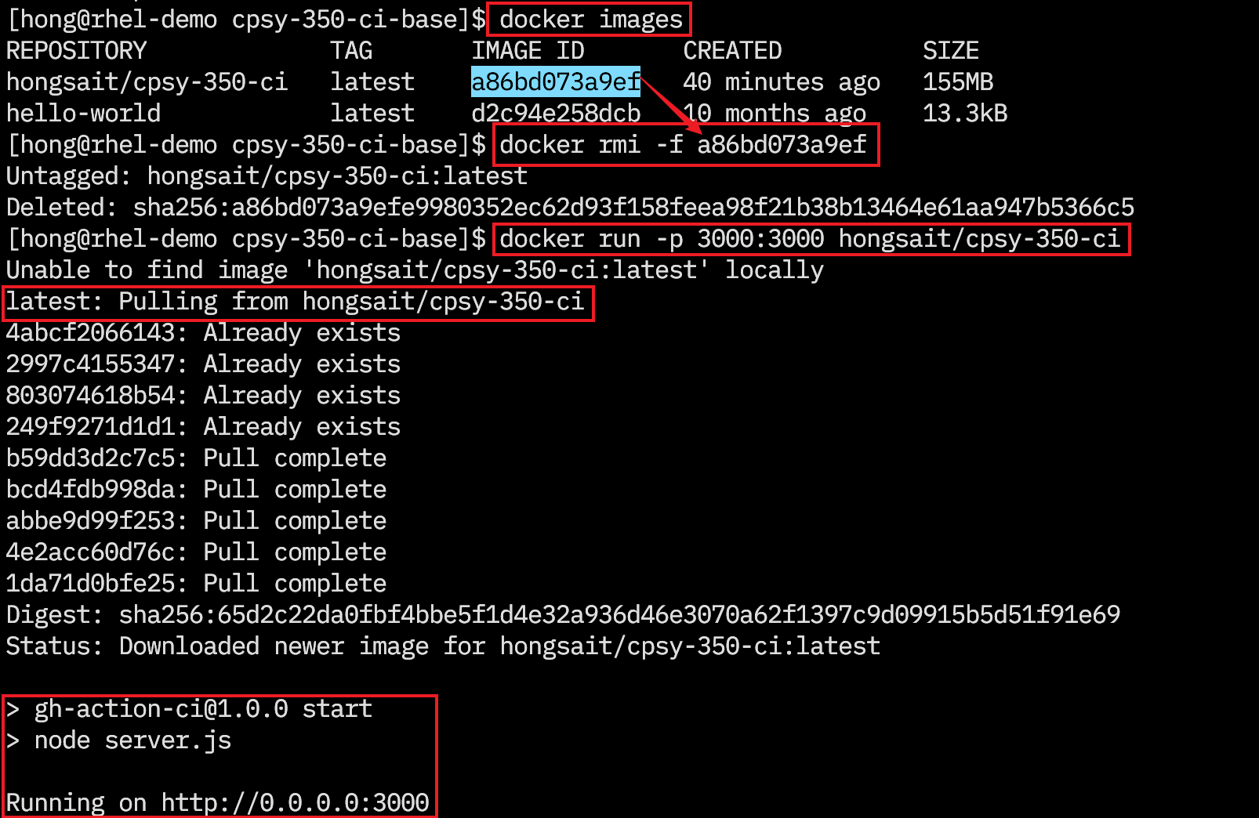

Use cURL or a web browser to access the web application.  
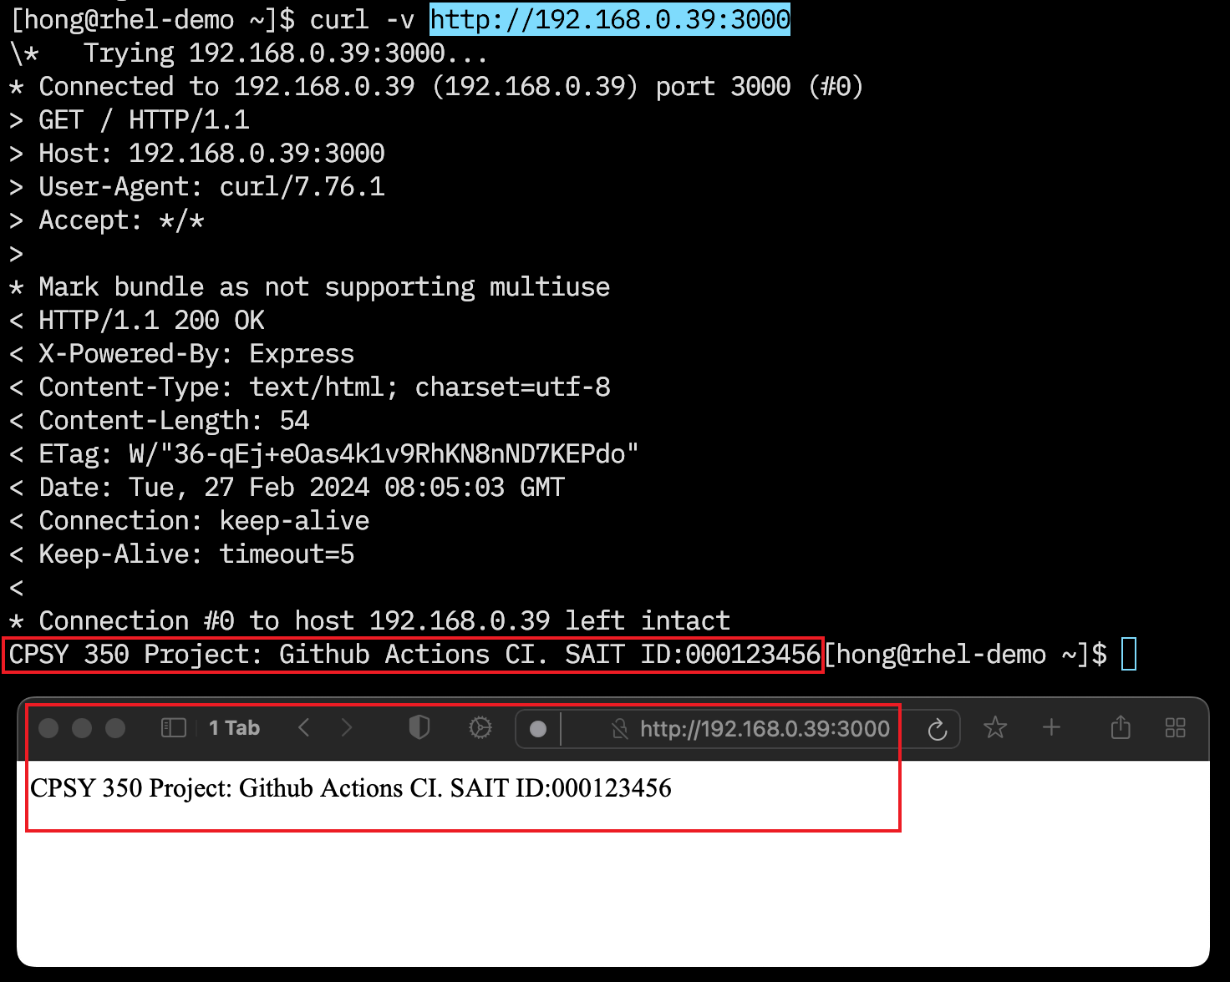

Figure 13: Run and Access Containerized Web Application

© 2024, Southern Alberta Institute of Technology

## Marking Criteria

|  |  |  |  |  |  |
| --- | --- | --- | --- | --- | --- |
| **Criteria** | **Poor 0/5** | **Satisfactory 1/5** | **Good 2/5** | **Excellent 5/5** | **Marks** |
| **Demo 1: Push Code to GitHub** | Fails to push code to GitHub. | N/A | N/A | Successfully pushes code to GitHub. | /10 |
| **Demo 2: Create GitHub Actions Secrets** | Fails to create GitHub Actions secrets. | N/A | N/A | Successfully creates GitHub Actions secrets. | /5 |
| **Demo 3: Demonstrate workflow trigger** | Fails to trigger the first workflow job. | N/A | N/A | Successfully triggers the first workflow job. | /5 |
| **Demo 4: Demonstrate the first workflow job** | Fails to pull code from repository. | Pulls code but fails to build or test. | N/A | Successfully pulls, builds, and tests the web app. | /35 |
| **Demo 5: Demonstrate the second workflow job** | Fails to build the container image or to demonstrate job dependency. | Builds the container image but fails to publish it to Docker Hub. | N/A | Successfully builds and publishes the container image. | /40 |
| **Demo 6: Demonstrate Running the container** | Fails to pull or run the container image. | Pulls and runs the container image but fails to access the web app. | N/A | Successfully pulls and runs the container image. Successfully accesses the web app. | /5 |
| **Total** | | | | | **/100** |

# Resources

* [Containerize a Node.js application](https://docs.docker.com/language/nodejs/containerize/) (<https://docs.docker.com/language/nodejs/containerize/>)
* [Dockerfile reference](https://docs.docker.com/engine/reference/builder/) (<https://docs.docker.com/engine/reference/builder/>)
* [Git cheat sheet](https://training.github.com/downloads/github-git-cheat-sheet/) (<https://training.github.com/downloads/github-git-cheat-sheet/>)
* [Continuous integration with GitHub Actions](https://www.youtube.com/watch?v=cyh8DU2QPzg) [1:55:25] (<https://www.youtube.com/watch?v=cyh8DU2QPzg>)
* [Building and testing Node.js - GitHub Docs](https://docs.github.com/en/actions/automating-builds-and-tests/building-and-testing-nodejs) (<https://docs.github.com/en/actions/automating-builds-and-tests/building-and-testing-nodejs>)

# References

Docker Inc. (2024). Docker Engine and Docker Desktop. [Computer software]. Retrieved from <https://hub.docker.com>

GitHub, Inc. (2024). GitHub Actions. [Computer software]. Retrieved from <https://docs.github.com/en/actions>